**IN CLASS # 3**

1. From the tensile stress-strain behavior for the brass specimen shown in the figure, determine the following:
2. The modulus of elasticity
3. The yield strength at a strain offset of 0.002
4. The maximum load (at tensile strength) that can be sustained by a cylindrical specimen having an original diameter of 12.8 mm.
5. The change in length of a specimen originally 250 mm long that is subjected to a tensile stress of 345 MPa **( point A)**.

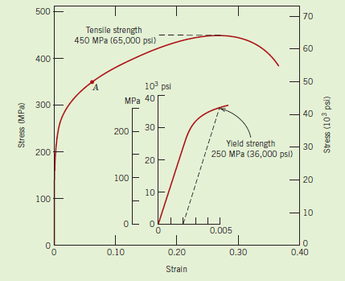

1. A cylindrical specimen of steel having an original diameter of 12.8 mm is tensile-tested to fracture and found to have an engineering fracture strength σf of 460 MPa. If its cross-sectional diameter at fracture is 10.7 mm, determine:
2. The ductility in terms of percent reduction in area
3. The true stress at fracture.